A D Patel Institute of Technology

## (A Constituent College of CVM University) New V. V. Nagar

**COMPUTER PROGRAMMING DEPARTMENT**

**MINI PROJECT (202040601)**

**A.Y. 2022-23 EVEN TERM Proposal on**

***Deep learning for song Recommendation***

**Submitted By**

## Name of Student :Badreshiya Darshit Enrolment Number : 12102040601011

**Name of Student :Neel Diyora**

**EnrolmentNumber :12102040601049 Name of Student :Rushi Katrodiya Enrolment Number : 12102040601063**

# Guided By

**Prof. Sheetal Macwan**

This is to certify that the Mini Project Report submitted entitled “Deep learning for song Recommendation” has been carried out by Badreshiya Darshit (12102040601011) under guidance in partial fulfillment for the Degree of Bachelor of Engineering in Computer Engineering, 6th Semester of A D Patel Institute of Technology, CVM University, New Vallabh Vidyanagar during the academic year 2022-23.

Prof. Sheetal Macwan Prof. Dr Bhagirath Prajapati

Internal Guide Head of Department

This is to certify that the Mini Project Report submitted entitled “Deep learning for song Recommendation” has been carried out by Neel Diyora (12102040601049) under guidance in partial fulfillment for the Degree of Bachelor of Engineering in Computer Engineering, 6th Semester of A D Patel Institute of Technology, CVM University, New Vallabh Vidyanagar during the academic year 2022-23.

Prof. Sheetal Macwan Prof. Dr Bhagirath Prajapati

Internal Guide Head of Department

# CERTIFICATE

This is to certify that the Mini Project Report submitted entitled “Deep learning for song Recommendation” has been carried out by Rushi Katrodiya (12102040601063) under guidance in partial fulfillment for the Degree of Bachelor of Engineering in Computer Engineering, 6th Semester of A D Patel Institute of Technology, CVM University, New Vallabh Vidyanagar during the academic year 2022-23.

Prof. Sheetal Macwan Prof. Dr Bhagirath Prajapati

Internal Guide Head of Department

# ACKNOWLEDGEMENT

We extend our heartfelt gratitude to all those who contributed to the successful completion of the project titled " Deep learning for song Recommendation”. First and foremost, we express our deepest appreciation to our supervisor Prof. Sheetal Macwan whose guidance, support, and invaluable insights have been instrumental throughout this endeavor. Your mentorship has helped shape our ideas and refine our approach, and we are immensely grateful for your patience and encouragement.

We would like to thank the faculty and staff of A D Patel Institute of Techonolgy for providing us with the resources and infrastructure necessary for conducting our research. Your support has been indispensable in enabling us to pursue our academic goals. We are indebted to our peers and colleagues for their constructive feedback and suggestions, which have greatly enriched our project.

Thank you.

# ABSTRACT

This project focuses on developing a web-based Song Recommendation System utilizing facial expressions, powered by machine learning. Our initial phase involved careful consideration of project definitions, leading to the selection of this innovative concept. Drawing insights from research papers, we constructed UML diagrams to map out the system's conceptual design and object relationships, visually representing functionalities associated with each element. Emphasis was placed on creating a seamless user interface, integrating intuitive features like navigation menus, search filters, and user profiles to enhance user experience. By leveraging facial expression analysis and Spotify integration, our system predicts emotions from live webcam feeds and recommends playlists aligned with users' moods, providing an engaging and personalized music streaming experience.

# LIST OF FIGURES

Figure 1 Timeline chart 6

Figure 2 ER diagram 7

Figure 3 Activity diagram 8

Figure 4 Class diagram 8

Figure 5 Flow chart 9

Figure 6 Front end 10

Figure 7 Mood detection & recommendation 10

## TABLE OF CONTENT

|  |  |
| --- | --- |
| Chapter | Page No. |
| 1 Introduction |  |
| 1.1 Problem Statement | 1 |
| 1.2 Project summary and introduction | 1-2 |
| 1.3 Aim and objective of project | 2 |
| 2 System analysis |  |
| 2.1 Motivation | 3 |
| 2.2 Brief Literature survey | 3-4 |

1. Design: analysis, design methodology
   1. H/W and S/W requirement 5
   2. Program/module specification 5-6
   3. Timeline chart 6
   4. UML diagrams 7-8
2. Implementation
   1. System flow 9
   2. Module specification (Screenshot of working module) 10
   3. Results
3. Conclusion and Future work 11
4. References 12
5. **Introduction**

# CHAPTER 1

### Problem Statement:

The acknowledged significance of music in influencing an individual's emotions has been widely recognized. The ability of both primitive and modern individuals to find relaxation and solace in the melodic strains of music after a day's toils and hard work is evident. Scientific studies have demonstrated that the rhythm inherent in music serves as a powerful tranquilizer. Despite this recognition, a prevalent challenge persists in the realm of music consumption - the difficulty of selecting songs that precisely align with an individual's current emotional state.

To address this challenge, the problem at hand is to design and implement a real-time music player that leverages machine learning to dynamically select and recommend music based on the user's current emotional state. The goal is to create an intelligent system capable of discerning the user's emotions and preferences in real time, providing a personalized and emotionally resonant music experience. This solution aims to enhance user satisfaction and engagement with music by eliminating the hurdle of manual song selection and intuitively tailoring the music playlist to match the user's emotions.

### Project Summary:

The project focuses on developing a web-based 'Song Recommendation System by Facial Expression using machine learning. Through careful selection and analysis, the project team has chosen this innovative approach, leveraging the FER 2013 dataset and Spotify integration. The system employs UML diagrams to conceptualize its design and ensure seamless functionality. Emphasis is placed on creating an intuitive user interface with features such as navigation menus and search filters. The model predicts user emotions from live video feeds, tailoring song recommendations accordingly. Further evaluation of model accuracy through training and fine-tuning is ongoing to enhance performance.

Overall, the project aims to provide a visually appealing and responsive music recommendation experience based on facial expressions of mood.

### Aim and Objective of project:

Aims:

* + - To provide a solution for the substantial method of using a music player by incorporating emotion detection.
    - To design and implement a reliable CNN classifier to distinguish between different facial expressions

Project Objective:

* + - * General Objective

The main objective of this project is to develop the “Emotion Based Music Player” for all kinds of music lovers which aimed to serve as a platform to assist individuals to play and listen to the songs according to his emotions. It is aimed to provide a better enjoyment of entertainment to the music lovers.

* + - * Specific Objective:
        + To propose a facial expression detection model to detect and analyze the emotion of an individual.
        + To accurately detect the four basic emotions, namely normal, happy, sad and surprise.
        + To integrate the music player into the proposed model to play the music based on the emotions detected**.**

1. **System Analyses**

# CHAPTER 2

### Motivation:

The main motive behind implementing song recommendation system using facial expression is to offer several potential needs and benefits, for individual users and in broader terms, by going beyond traditional recommendation methods based on listening history or genre this method directly links music selection to the user's current emotional state. Accordingly for emotion detection research on this technology could contribute for a better understanding of how facial expressions relate to emotions and how music can relate them .

### Brief Literature Surveys:

The review is done to get insights into the methods, their shortcoming which we can overcome. A literature review, a litera-ture survey is a text of a scholarly paper, which includes the current understanding along with great findings, as well as theo-retical and methodological contributions to a particular topic. The latent qualities of humans that can provide inputs to any system in various ways have brought the attention of several learners, scientists, engineers, etc. from all over the world. The current mental state of the person is provided by facial expressions. Most of the time we use nonverbal clues like hand gestures, facial expressions, and tone of voice to express feelings in interpersonal communication. Preema et al [2] stated that it is very time-consuming and difficult to create and manage a large playlist. The paper states that the `music player itself selects a song according to the current mood of the user. The application scans and classifies the audio files according to au-dio features to produce mood-based playlists. The application makes use of the Viola-Jonas algorithm that is used for face detection and facial expression extraction. Support Vector Machine (SVM) was used in the classification extracted features into 5 major universal emotions like anger, joy, surprise, sad, and disgust Yusuf Yaslan et al. proposed an emotion-based music recommendation system that learns the user's emotion from signals obtained through wearable e computing

devices that are integrated with galvanic skin response (GSR) and photoplethysmog-raphy (PPG) physiological sensors in their paper [3].

Emotions are a basic part of human nature. They play a vital role throughout life. In this paper, the emotion recognition problem is taken into account as arousal and valence prediction from multi-channel physiological signals. In [2]Ayush Guidel et al stated that human being’s state of mind and currentemotional mood can be easily observed through their facial expressions. This system is being developed by taking basic emotions (happy, sad, anger,excitement,surprise,disgust, fear, and neutral) into consideration. Face detection in this project is being imple-mented by using a convolutional neural network. Music is usually told as a "language of emotions" throughout the planet. The paper proposed by Ramya Ramanathan et al [1] conveyed the intelligent music player using emotion recognition. Emotions are a very basic part of human nature. The user's local music selection I initially grouped based on the emo-tion conveyed by the album. This is often calculated taking into consideration the song's lyrics. The paper specifically makes a specialty of the methodologies available for detecting human emotions for developing emotion-based music players, the approach a music player follows to detect human emotions, and the way it is ideal to apply the proposed system for emotion detection.

It additionally offers a brief idea about our systems working,playlist generation, and emotion classification.CH Radhika et al [3] advised manual segregation of a playlist and annotation of songs, following the current emotional state of a user, as a labor-intensive and time-consuming task.Numerous algorithms had been proposed to automate this manner. However, the prevailing algorithms are slow, increase the overall cost of the system by using additional hardware (e.g., EEG structures and sensors), and feature much less accuracy. The paper presents an algorithm that automatically does the pro-cess of generating a playlist of audio, based on the facial expressions of a person, for rendering salvage of time as well as labor, invested in performing this process manually.

# CHAPTER 3

## Design: analysis, design methodology and implementation strategy

### Hardware and software requirements:

1. Hardware Requirements
   * Processor - Intel Pentium 4 or equivalent
   * RAM - Minimum of 4 GB or higher
   * HDD - 100 GB or higher
   * Architecture - 32-bit or 64-bit
   * Monitor - 15’’ or 17’’ color monitor
   * Mouse - Scroll or optical mouse
   * Keyboard - Standard 110 keys keyboard
   * Web camera
2. Software Requirements
   * Operating System – Windows 10 or 11
   * Flask==2.2.2
   * spotipy==2.22.0
   * pandas==1.5.2
   * gunicorn==20.1.0
   * opencv_python_headless==4.7.0.68
   * numpy==1.24.1
   * Pillow==9.4.0
   * tensorflow==2.11.0

### Program/module specification :

* HTML document with a title "Emotion Music Recommendation".
* Included Bootstrap and custom CSS.
* Background styling with an image.
* Header with a gradient text "SOUNDTRACK YOUR MOOD".
* Two main sections: "Emotion Detector" and "Song Recommendations".
* Emotion Detector section with an image element.
* Song Recommendations section with an empty div
* Overall layout with specified styles for alignment and appearance.
* Training the emotion recognition model based on the FER 2013 dataset.
* Connection to the Spotify API to fetch a playlist of songs according to the predicted emotion
* The two empty div in the layout , one used an frame for video capturing of user through web cam and another for displaying playlist of recommended songs.

### Timeline Chart:

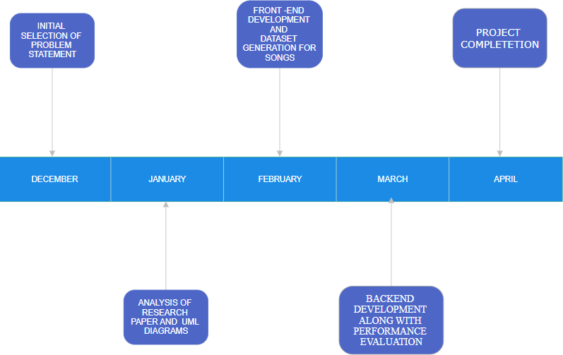

*Figure 1 Timeline chart*

### UML Diagrams:

* **ER Diagram**

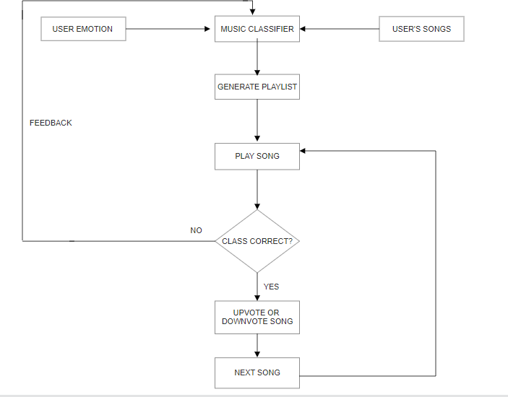

*Figure 2 ER diagram*

### Activity Diagram

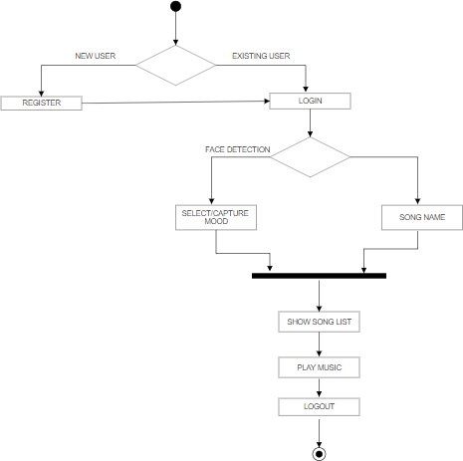

**Class Diagram**

*Figure 3 Activity diagram*

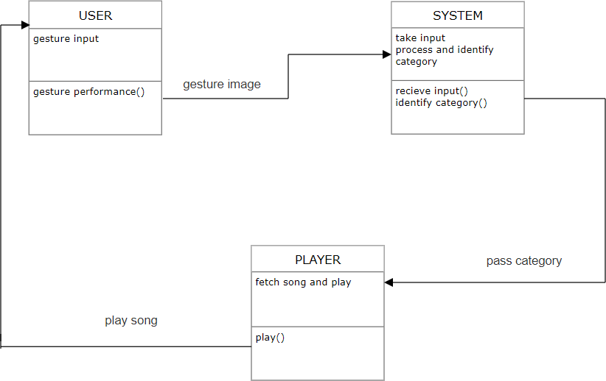

*Figure 4 Class diagram*

# CHAPTER 4

## Implementation:

### System flow:

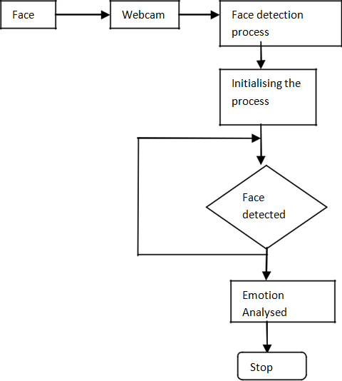

*Figure 5 Flow chart*

## Module Specification:

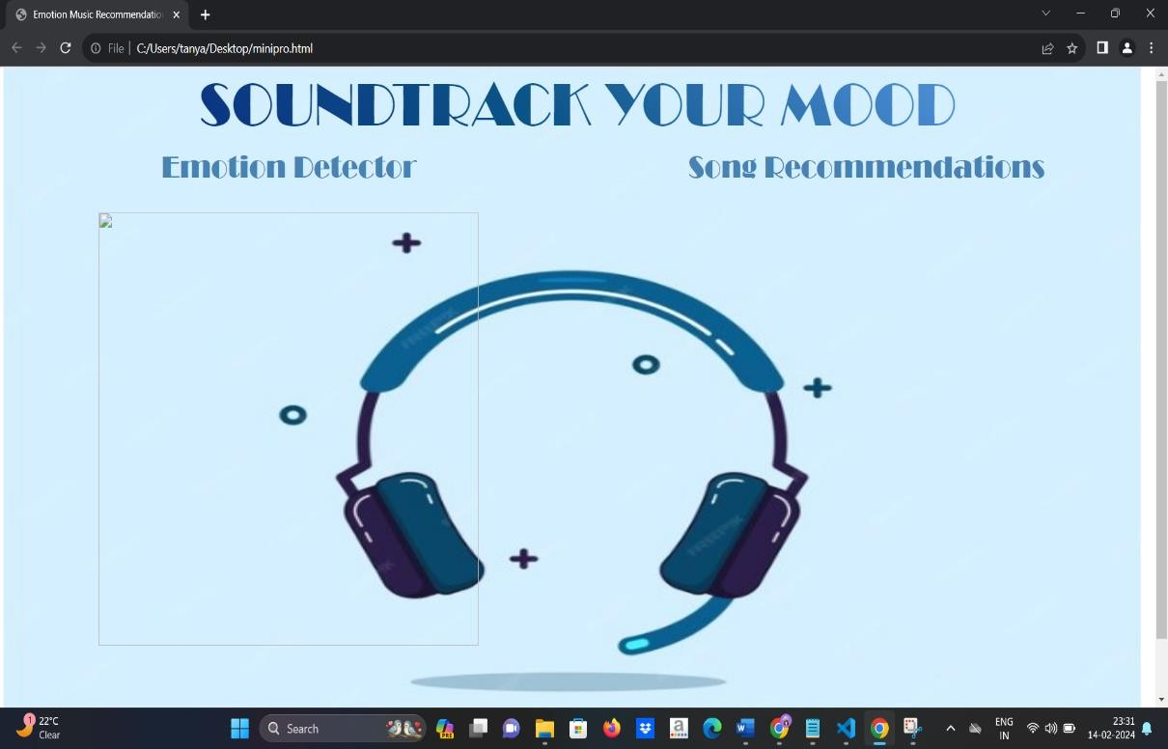

*Figure 6 Front end*

## Result:

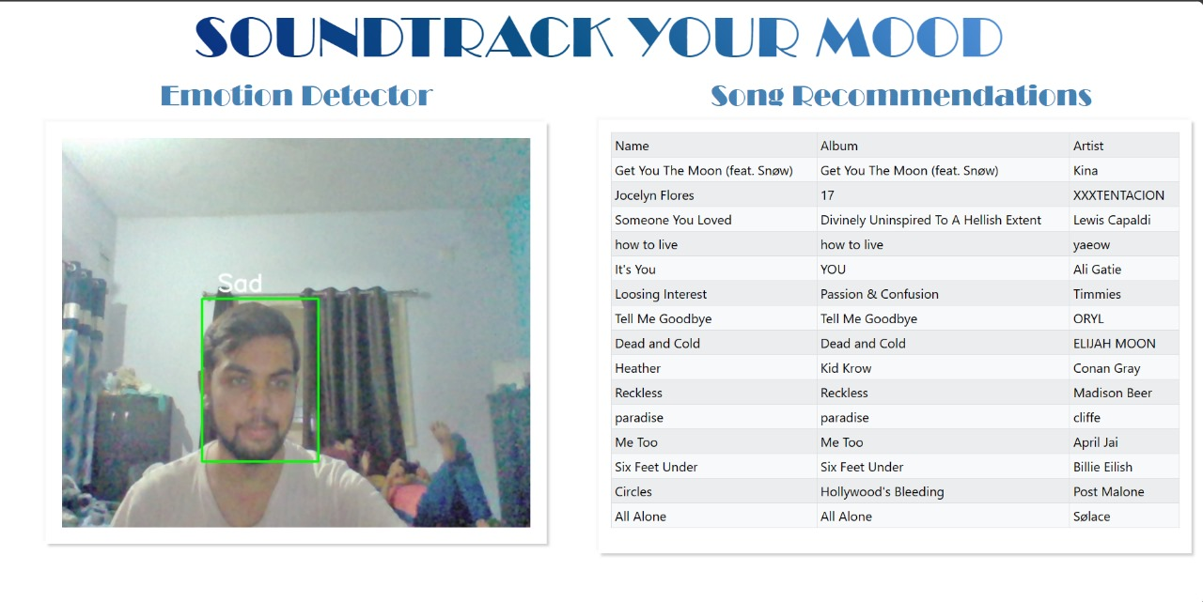

*Figure 7 Mood detection & recommendation*

## CONCLUSION

The project currently is in a fully functional state. Live detection of facial expressions provides good frame rates. The project successfully combines emotion recognition with music recommendation based on facial expressions. By detecting the user's emotion in real-time, the project provides personalized song recommendations that match the user's mood. The integration with the Spotify API ensures a wide range of music options for the user. By incorporating facial emotion recognition technology into music recommendation systems, it will provide the personalized recommendations that align with the listener's current emotional state.

After training the model locally the accuracy of around 66% is achieved. The project can be further improved by fine-tuning and training the emotion recognition model to enhance its accuracy as some challenges and limitations might arise to this system, but research & development can lead to more accurate and effective systems , that can provide a more accurate personalized music listening experience

## FUTURE WORK

-Instead of CSVs, create a database and connect it to application. The DB will fetch songs for recommendations and new songs can be updated directly onto database

* Add a feature which will update specified playlists for better and more recent recommendations, a specific day over a fixed duration say every sunday and append it to database
* Directly play the song or redirect to the song on Spotify when user clicks on it.
* Rewrite code such that Video Streaming is done on client side instead of server side so as it make the app deployable

## REFERENCES

[1]. Shubham Kulkarni , Sanskruti Lingawar , Suvarna Patil and Dinesh Bhadane , “Facial Emotiion Based Music Recommendation System” , International Journal Of Novel Research And Development (IJNRD) | Volume 8 Issue : 5 May 2023 , pp. 725 – 729

[2]. S. Sunitha , V. Jyothi , P. Ramya and S. Priyanka , “Music Recommendation Based On Facial Expression By Using Deep Learning” , International Research Journal Of Modernization in Engineering Technology and Science | Volume 5 Issue : 01 Jan 2023 , pp. 927 – 934

[3]. Madhuri Athavle , Deepali Mudale , Upasana Shrivastav and Megha Gupta , “Music Recommendation Based on Face Emotion Recognition” , Journal Of Informatics Electrical andElectronics Engineering | Volume 02 Issue : 02 2021 , pp. 1 – 11

[4]. Renuka R. Londhe, Dr. Vrushshen P. Pawar, “Analysis of Facial Expression and Recognition Based On Statistical Approach”, International Journal of Soft Computing and Engineering (IJSCE) Volume-2, May 2012.

[5]. Anagha S.Dhavalikar and Dr. R. K. Kulkarni, “Face Detection and Facial Expression Recognition System” 2014 Interntional Conference on Electronics and Communication System (ICECS -2014).